Automation and Robotics - by Knowledge flow

09-02-2016

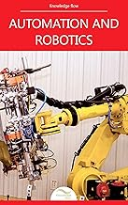

# 1. Introduction to Automation and Robotics

# 2. Applications of Robots

# 3. Basic Structure of Robots

# 4. Control Loops of Robotic Systems

# 5. Hydraulic Systems

# 6. Direct Kinematic Analysis

# 7. Principles of DH Method

# 8. Principles of Quaternion

# 9. Programming of Robots

# 10. Sensors of Robots